**Name:** Mallela Kranthikumar

**Batch:** June 01, 2022

**Project: Web Servers Installation**

**APACHE WEB SERVER INSTALLATION ON UBUNTU:**

1. Installed Apache Webserver on the Ubuntu Machine by running the ( apt install apache2 -y ) command.
2. Restarted the Apache services by running ( systemctl restart apache2.service ) command.
3. Checked Apache services by running ( systemctl status apache2.service ) command.
4. Went to cd /var/www/html/ and created index.html file.
5. Wrote Basic Html program on demo.html file

1. Access the Webserver by using the Public IP address with port number 80.

**NGINX WEBSERVER INSTALLATION ON AMAZON LINUX 2:**

1. Installed extra package by running the ( amazon-linux-extras install epel ) command.
2. Instlled nginx by running the ( yum install nginx command )
3. Checked nginx version by running the ( ngnix -v ) command

1. Wrote script on nginx.repos by running the ( vim /etc/yum.repos.d/nginx.repo ) command.

1. Restart the ngnix by running the ( systemctl restart nginx.service ) command.
2. Checked ngnix status by running the ( systemctl status nginx.service ) command.
3. Public IP is configured with port 80 by running the ( curl localhost:80 ) command.

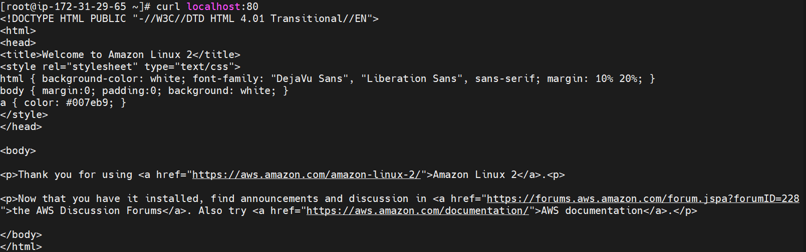

1. Taken Instance Public IP address with port 80 and pasted it on the browser to check Nginx webserver is working or not.

**IIS INSTALLATION:**

1. Taken Windows 2012 Server and launched instances.
2. Connected through RDP Client by downloading it and decrypting the password.
3. Connected to the server through RDP Client.
4. Opened Server Manager and installed Web Server IIS role.

1. Opened C drive went to inetpub/wwwroot deleted two files.
2. Created a new text file and wrote a basic Html script and later saved it as index.html
3. Taken the Public IP address of the server and pasted it on the browser to check whether the server is connected or not.
4. Successfully connected to the IIS Webserver.